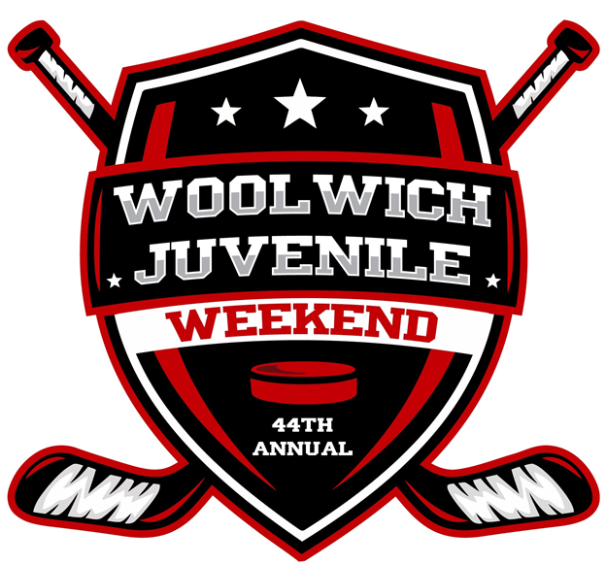

Woolwich Juvenile Weekend 2019 – OFFICIAL TOURNAMENT RULES

This is an OMHA sanctioned tournament and all tournament games are considered OMHA games for the purpose of rule interpretations. OMHA rules will prevail with the following additions:

- A. Any player or team official incurring the following penalties will be suspended from further participation in the tournament:
- A 2nd game misconduct
- A fighting major
- A gross misconduct
- A match penalty

B. Game Misconducts – see OMHA Manual of Operations

- Mouth guards are MANDATORY and must be worn by all players who are governed under the OMHA.

- All teams must register and present their approved electronic team rosters (if not already submitted) ONE HOUR before the scheduled face-off time of their FIRST game. Registration will take play at the WMC – TOURNAMENT OFFICE (ELMIRA) No exceptions.

- A member of the Coaching Staff must report to the Tournament Headquarters to complete a game sheet prior to each game. You will NOT be permitted to remove the electronic game sheet (iPad) from the Headquarters area.
- An Affiliate Player (AP) who is used in the Tournament must be listed on the approved electronic roster provided. An AP can only be used to replace a regular rostered player – not in addition (unless otherwise approved by the Tournament Chair). The number of players dressed on the bench during a tournament game should not exceed the number of regular rostered players. Any player in the Tournament may only play for one team.

- Each team will carry home and away jerseys. Home will wear light colored jerseys and visitors will wear dark. If a conflict arises regarding jersey colors, the VISITING team will change jerseys.

- All teams must be prepared to go on the ice 15 MINUTES before their scheduled game time. Dressing rooms must be vacated within 30 minutes of your game completion. Teams will be held responsible for any damages caused to the facilities utilized for the Tournament. A damage charge may be assessed if there is damage done to any of the change rooms or facilities.

**It is the Team Officials responsibility to ensure their dressing room is locked at all times. Woolwich Minor Hockey, The Tournament Committee and the Township of Woolwich will accept no responsibility for the loss/theft of, or damage to any personal property left in the dressing room at any time.**

- i) Game Lengths – all games will have a 3-minute warm up and will consist of the following:

ROUND ROBIN
10-15-FLOOD-15

FINALS
15-15-FLOOD-15

ii) Game Play:
All games will be stop time periods. No Team Official or Player is allowed on the ice surface until the Olympia has left and the resurface door is closed.
Each team will be permitted 1 x 30 second time out during Round Robin play
IF THE ROUND ROBIN GAME IS TIED AFTER REGULATION, teams will immediately commence a shootout, with the following format:

- Home Team decides who shoots first;
- Designated shooters will alternate shots;
- Team Official must designate their initial 3 shooters by filling out the “Shootout Ballot” in the Tournament HQ PRIOR to their games. This form will be provided to the Timekeepers before the start of each game;
- If score remains tied after the initial 3 shooters, new players will participate in a sudden death shootout;
- Players who have already shot, may not shoot again, until all eligible players have taken a shot; and
- Penalized players with time remaining on their penalty, are NOT eligible for the shootout.

- Point structure for game in preliminary rounds are as follows:

- GAME WIN IN REGULATION: 3 points
- SHOOTOUT WIN: 2 points
- SHOOTOUT LOSS: 1 point
- REGULATION LOSS: 0 points

- Any team failing to appear for their scheduled game time without just cause will forfeit the game. 3 points and a 3-0 score will be awarded to the opposing team.

- After the completion of the Round Robin, teams will be ranked based on the number of teams in their respective division - see Advancement Criteria (below).

**THE TOP TWO TEAMS WITH THE HIGHEST POINT TOTAL OVERALL AT THE END OF THE ROUND ROBIN GAMES (4 games per team), WILL ADVANCE TO THE CHAMPIONSHIP FINAL**

TIE BREAKING RULES

The following is the tie-breaking rules for the Divisional Qualifying Rounds.

Two Teams Tied:
1.0 The winner of the Round Robin game between the two tied teams gains the higher position

1.1 The team with the most wins in the Round Robin gains the higher position

1.2 If the two teams are still tied after 1.1 has been applied, then the team with the best goal differential gains the higher position. The goal differential of a team is to be determined in the following manner:

Total number of goals FOR, divided by the total number of goals FOR plus the total number of goals AGAINST.

NOTE: All Round Robin games are included

Example: For = 10 goals
Against = 4 goals
Goal Differential: 10
10+4=.714

The higher goal differential value gains the higher position.

1.3 If the two teams are still tied after 1.2 has been applied, the team with the least number of penalty minutes throughout all of the Round Robin games, gains the higher position.

1.4 If the two teams are still tied after 1.3 has been applied, then the team which scored the first goal in the game between the tied teams gains the higher position.

1.5 If the two teams are still tied after 1.4 has been applied, a single coin toss will determine which team gains the higher position.

Three or More Teams Tied:
When three or more teams are tied, the three or more team tiebreaker is used to determine the seeding of 1st, 2nd, 3rd,etc. If any step in the tiebreaker only seeds one team, that team will assume that position. The 3-team or more tiebreaker will continue to determine the seeding of the remaining teams. At no time will the teams using this formula go back to the two team tiebreaker.

2.0 If 3 teams or more are tied, the point record established among the tied teams only will be used as the first tie breaking formula in deciding which team(s) shall advance.

2.1 The team with the most wins (among the tied teams) would gain the highest position.

2.2 If the teams are still tied after 2.1 has been applied, then the team with the best goal differential gains the highest position (see 1.2 above for the goal differential calculation).

The exercise 2.2 establishes the team or teams with the highest position by percentage. These teams will advance. If there are still teams tied, then 2.3 is applied. They do not go back to the "Two Team Tiebreaker".

2.3 If teams are still tied after 2.2, the team with the most goals for (all Round Robin/preliminary games played) will gain the higher position.

2.4 If the teams are still tied after 2.3 has been applied, the team with the least number of penalty minutes throughout all the Round Robin games will gain the higher standing.

2.5 If teams are still tied after 2.4 has been applied, a coin toss shall determine the higher standing. In a 3 team coin toss, the odd team gains the higher position and if necessary another coin toss will be held to determine the standing of the other two teams.

FINALS

*Each team is allowed one 30 second time out in the Championship game

Game Ties in the Championship Finals after Regulation Time

- In the event of a tie at the end of regulation time in the Championship Finals, a SUDDEN VICTORY FIVE (5) MINUTE OVERTIME will commence. The teams will NOT switch ends at the commencement of the overtime period – goalies will remain on the same end of the ice
- Teams will play a FIVE (5) minute sudden victory overtime period 4 on 4 plus goalies. Players may be changed at any time. Goalies may be “pulled” at any time and a substitute player from the bench be used.
- If still tied after the 5-minute 4 on 4 overtime period, the teams will proceed to a shoot out (see rule 15)

Penalties During the 4 on 4 Sudden Victory Overtime Period
If a penalty occurs during the 4 on 4 overtime period, the teams play 4 on 3. If a SECOND penalty is called on the SAME TEAM, and the first penalty has not expired, the second penalized player goes to the penalty box and it will be treated as a delayed penalty and time will commence when the first penalty expires. The first penalized player cannot re-enter the game until a stoppage of play after his/her penalty expires. The maximum a team may be at a disadvantage is 4 on 3. Penalties carry from period to period.

Overtime Shoot Out (Championship, Quarter Final & Semi Final Games)
Should the game remain tied after the 5 minute sudden victory overtime period, a SHOOT OUT will occur. Please note the following:
- Any player(s) serving a penalty at the end of overtime will not be eligible to participate in the shootout. The Coach must designate a shooter(s) to take his place immediately at the end of the 5 minute sudden victory overtime period
- Each team must designate 3 shooters (S1, S2, S3) on the Shootout Ballot prior to the start of the game
- All players except S1 shooters and goalies will be on the bench to start
- Shooters from both teams will shoot at the same time from the centre ice red line
- All 3 designated shooters from each team will shoot
- If still tied, each team will designate one shooter at a time until there is a winner. A player may not shoot for a second time until all players on the game sheet (except goalies) have shot
- Goalies that start the shootout must remain in net unless there is an injury

PLEASE NOTE

Any disputes arising during the Tournament, will be brought to the attention of the “In Charge” Tournament Committee Member. Decisions of the Tournament Committee Members are FINAL.

Team Officials are responsible for their team’s behavior/conduct on and off the ice. The Tournament Committee reserves the right to revoke any abusive individual’s privilege to be present at the arenas.

It is common to have Coaches and/or parents approach a Tournament Committee member protesting a suspension penalty issued by a referee. It must be emphasized to all Coaching Staff and Parents that the Tournament Committee cannot and will not overturn any penalty issued before, during or after a game regardless of the circumstances. The suspension appeal process can be found in the OMHA Manual of Operations.

The Sponsors of the Tournament, its Officials, Township of Woolwich Staff and persons connected with the Tournament will not be held liable for any injury or accident that may be incurred by any player or team official while participating in the coming/going to or from the Tournament.

