WRAPPING IT UP
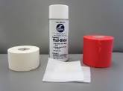
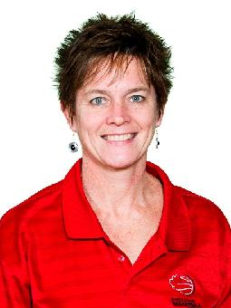
A course for Minor hockey Trainers and Coaches
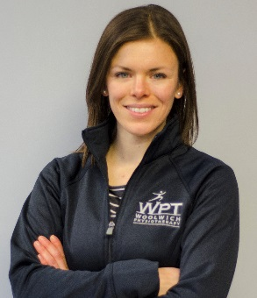
Where? Woolwich Physiotherapy clinic. 8-25 Industrial Drive, Elmira
Instructors: Sheila Forler Bauman, Sport Physiotherapist
Katie Mitchell, Certified Athletic Therapist, Physiotherapist
When? Wednesday Sept. 30 or Tuesday October 6 - 6:00 pm-9:00pm
Course Content:
1) An overview of taping and wrapping principles appropriate for management and prevention of common hockey injuries.
2) Practical hands on session focused on taping and wrapping techniques for common hockey injuries, including wrist and thumb sprains, AC joint sprains, ankle injuries, groin and thigh injuries.
Cost: WMHA will cover the cost includes course handouts, taping supplies and light refreshments.
Registration: Register by phone at Woolwich Physiotherapy (519-669-2578), by email at woolwichphysio@bellnet.ca or in person at the clinic.

In order to assure quality instruction /learning opportunities registration will be limited to 12 participants per session.
We hope you will join us for a fun and educational opportunity!!
